Déjà Vu and Vecu in Temporal Lobe Epilepsy

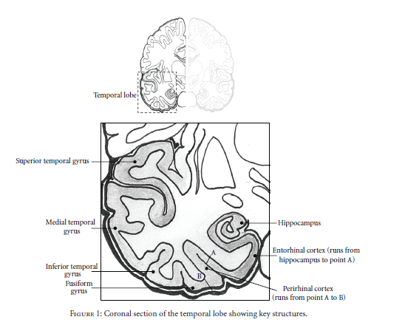
(Illman, 2012)

In Temporal Lobe Epilepsy there is a type of seizure that generates déjà vu and déjà vecu experiences. The brain areas affected correlate with areas affected by Havana Syndrome and the Harribance Configuration. Illman et al (2012) studied these experiences. déjà is ‘a stereotypical feeling of familiarity, recognition, or fear reminiscence that the patient recognized as abnormal’ (Illman et al, 2012, 6). In their study of Neuroimaging of patients that have these seizures they have identified key areas of the brain as being involved using PCA data analysis. They implicate the visual network (mesial temporal structures). Using metabolic studies to map out areas involved during seizures they found significant hypometabilism left hemisphere of déjà vu patients which is an area also involved in what Persinger has called sensed presences. Brain scientists believe déjà is a malfunction in memory consolidation, giving the false sense of having experienced something before, it does involve heavily the hippocampus and parahippocampal areas which as we have read may be a source of a singularity, that is memory is quantum and entangled. If entangled it may be that some people with different brain complexity that the norm have access to memories through entanglement. Both views involve memory consolidation and retrieval.
The researchers mention the work of Adachi et al, that found significant ipsilateral hypometabolism in parahippocampal regions (enterhinal and perirhinal cortices), superior temporal gyrus, superior temporal sulcus, buy no differentiation in the hippocampus. Illman et al confirmed mesial temporal lobe but not parietal cortex, but the superior temporal gyrus, “lending support to the thesis that the parahippocampal regions are specifically and independently involved in familiarity-based recognition and, hence, déjà vu experiences. Another researcher reviewed was that of Van Paesschon et al in TLE with abnormal amygdala measuring amgdala relaxation time AT² , abnormal AT² correlated to déjà experiences. They found that déjà is associated with the right amygdala, which is also a variance in easily hypnotizable people (McCarron, 2021, Ch. 11). They also found that in 80% of the patients there was sclerotic tissue found in Hippocampus, but all having abnormal AT² results even those without sclerotic tissue. Another researcher mentioned Guedj et al found parahippocampal hypometabolism in TLE without structural abnormality, that is no sclerotic tissue. In an MRI study there is a relationship between abnormal amygdala activation and a range of experiential phenomenon.

In other studies that used direct stimulation to TLE patients through implanted brain electrodes, the dreamy states of Hughling Jackson, or déjà, are created from spontaneous seizures through the stimulating the posterior hippocampus, then it propagates to the amygdala, then anterior hippocampus, then temporal neocortex, from lower depth to the surface, this pathway generated ‘dreamy states’ in 17 of 20 patients. In the opposite direction from outer surface to plumbed depths of the mind ‘dreamy states’ were created 8 of 15 attempts. It was also noted that superior temporal gyrus produces ‘dreamy states’. The Theta and Beta bands which showed importance in the Harribance Configuration also plays a role here there is a “...strong relationship in the theta range was observed between anterior hippocampus perirhinal region and visual areas (Illman, 2012, 7). Vignal et al found dreamy state comes from right side stimulation of the mesial temporal lobe, in tests on the left temporal lobe ‘dreamy states’ were produced 0 times. Whereas, the right produced dreamy states with the Amygdala responsible for 45%, hippocampus produced 37.5% of dreamy states.

In a study of déjà vecu Bartolomei et al found epileptic discharge restricted to entorhinal cortex may result in a pure form of déjà vecu but as activity is propagated to other hippocampal structure sand the amygdala, widespread functional activation of the fronto-termporal autobiographical memory network my result in a more intense visual mnestic experience. (Illman, 2012) So we see there may be a direct link to visual representations and the entorhinal cortex of the hippocampus. They also found Theta to be of relevance memory processing is reliant on synchronization of the MTL structures at the 4-8Hz frequency, “...déjà coupling and signal correlations between mesial temporal neural coupling between rhinal cortices, hippocampus and the amygdala in the theta and beta bands.” (Illman, 2012)

